ACTIVITIES (2015-16)

GUEST LECTURE BY D.USHA RANI H.O.D.OF MATHEMATICS V.R.S&Y.R.N COLLEGE ON HUMAN COMPUTER SAKUNTHALA DEVI

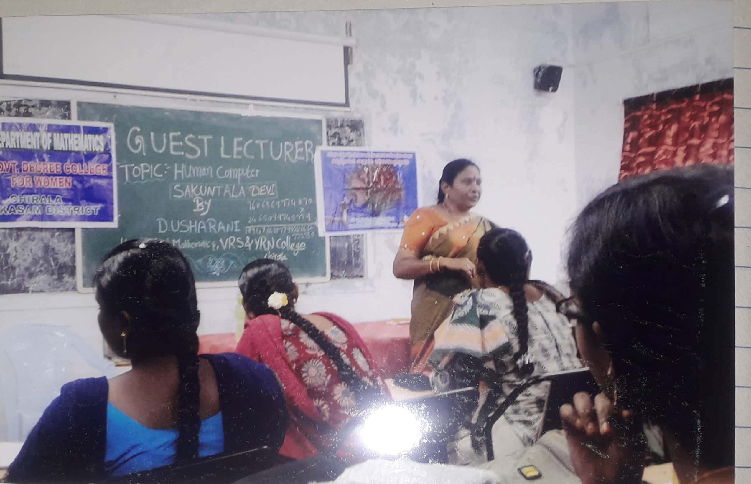

PPT PRESENTATION BY MATHEMATICS STUDENTS
